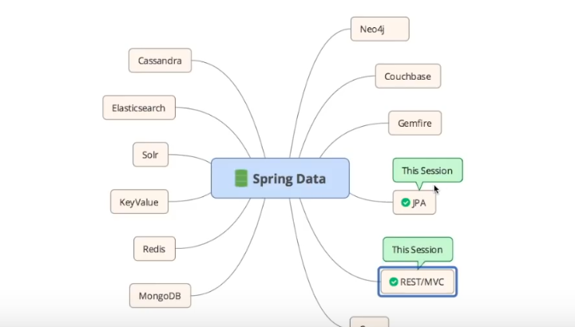

JAP is Java specification given by java for persistence data

Use JpaRepository<User,Long> for jpa.

JPA + MYSQL:

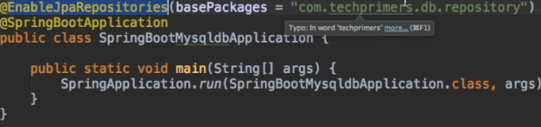

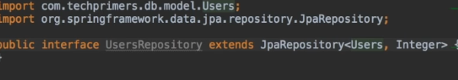

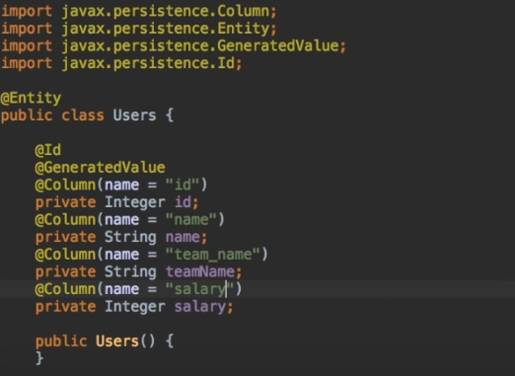

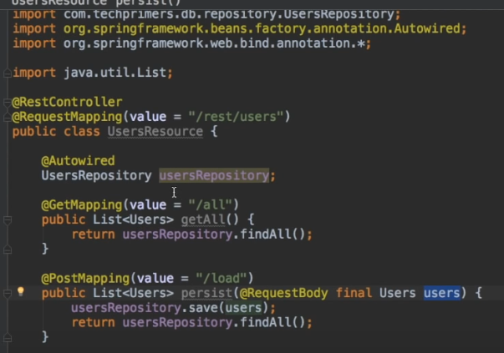

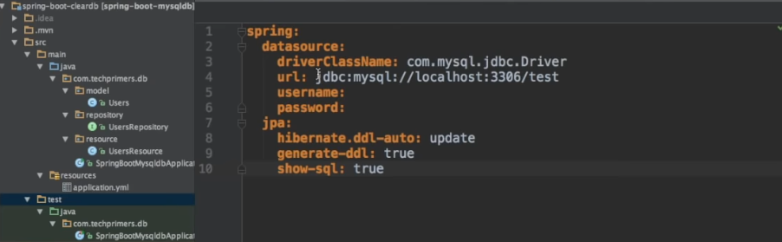

JPA + Hibernate + Mysql

Spring data jpa contains all the hibernate and orm everything

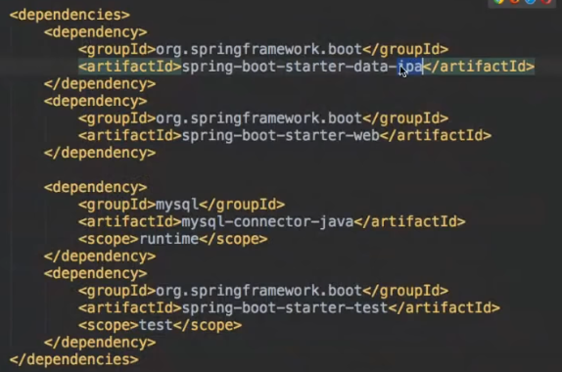

Relationship between the table :

@OneToOne

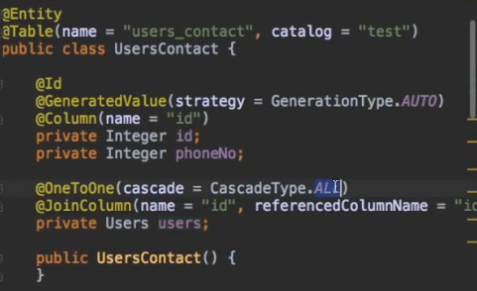

@OneToMany

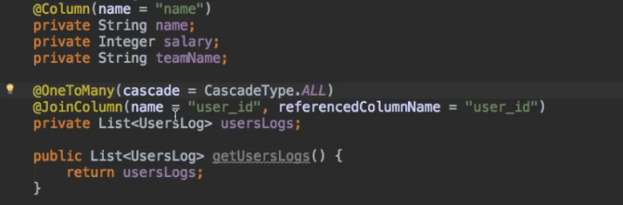

@ManyToOne

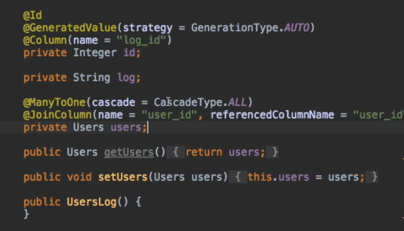

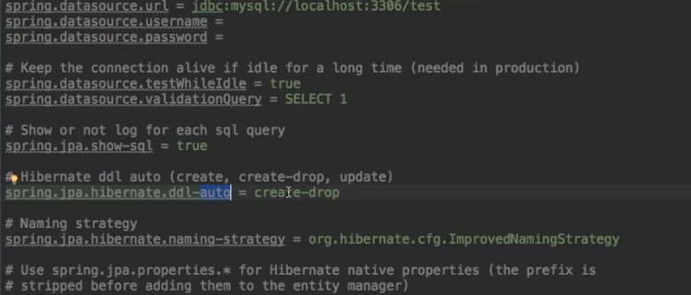

Spring.jpa.hibernate.ddl-auto = update

<https://www.roytuts.com/spring-boot-data-jpa-left-right-inner-and-cross-join-examples-on-three-tables/>